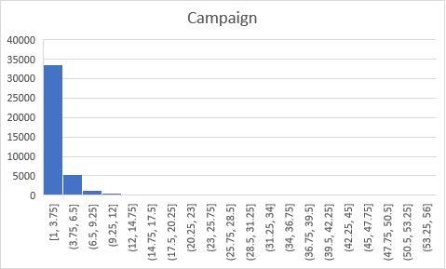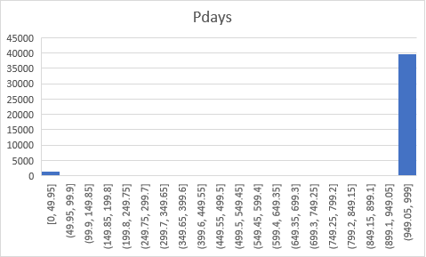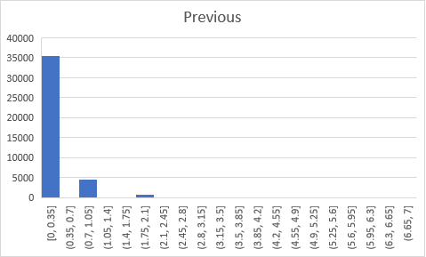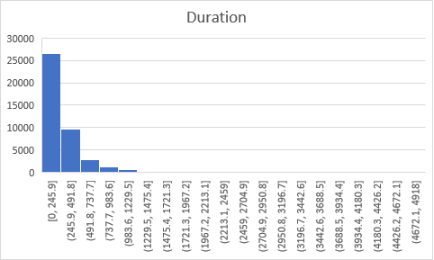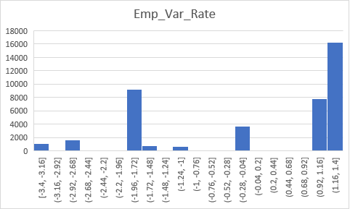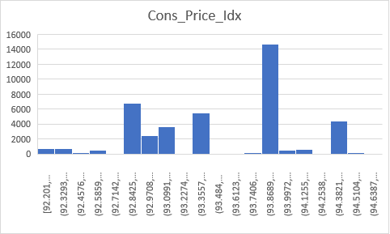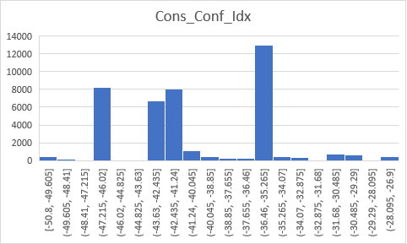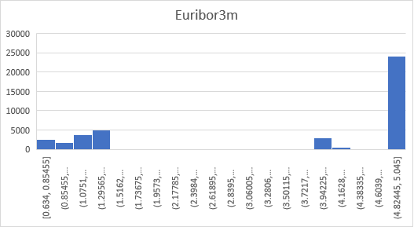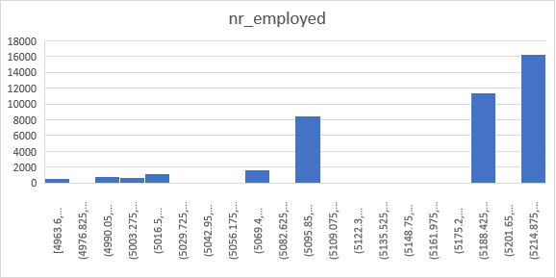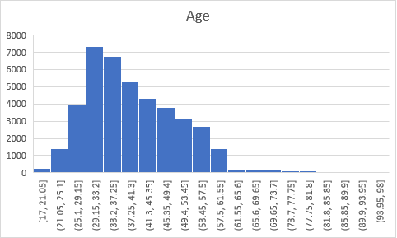

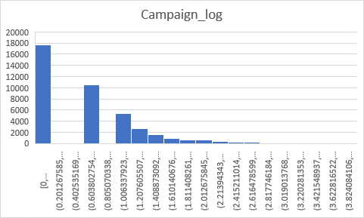

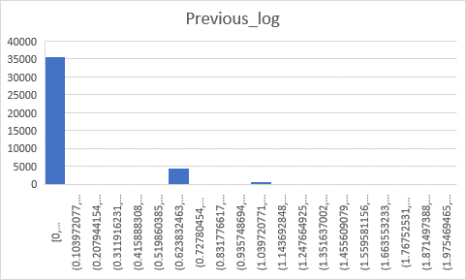

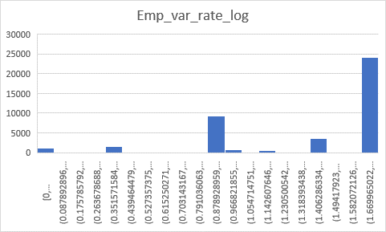

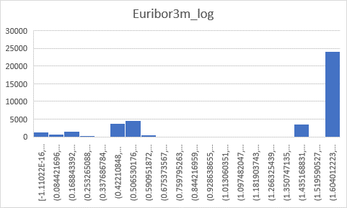

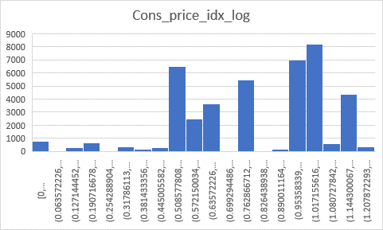

{'marital': {'married': 0, 'single': 1, 'divorced': 2}, 'default': {'no': 0, 'yes': 1}, 'housing': {'no': 0, 'yes': 1}, 'loan': {'no': 0, 'yes': 1}, 'contact': {'telephone': 0, 'cellular': 1}, 'month': {'may': 0, 'jun': 1, 'jul': 2, 'aug': 3, 'oct': 4, 'nov': 5, 'dec': 6, 'mar': 7, 'apr': 8, 'sep': 9}, 'day_of_week': {'mon': 0, 'tue': 1, 'wed': 2, 'thu': 3, 'fri': 4}, 'poutcome': {'nonexistent': 0, 'failure': 1, 'success': 2}}

log=['pdays', 'cons_conf_idx', 'campaign_log', 'previous_log', 'cons_price_idx_log', 'marital', 'contact', 'month', 'day_of_week', 'poutcome']

tree=['pdays', 'cons_conf_idx', 'nr_employed', 'campaign_log', 'previous_log', 'emp_var_rate_log', 'marital', 'contact', 'day_of_week', 'poutcome']